ASP.NET Core 8.0 Web API

Aim:
To implement Apache Kafka as a distributed streaming platform and demonstrate message publishing and consuming using Kafka in a C# application.
Objectives:
- To understand the Kafka architecture.
- To install and configure Apache Kafka.
- To start ZooKeeper and Kafka Server.
- To create a Kafka topic.
- To publish messages using Kafka Producer.
- To consume messages using Kafka Consumer.
- To demonstrate message streaming in a C# application.
Tools Required:
- Windows 11
- Java JDK 17
- Apache Kafka 2.7.0
- Visual Studio 2026
- .NET Framework / C#
- Command Prompt

Procedure

Step 1
Downloaded and extracted Apache Kafka 2.7.0 Binary package.

Step 2
Started the ZooKeeper server using the ZooKeeper configuration file.

Step 3
Started the Kafka Server and verified successful broker startup.

Step 4
Created a Kafka topic named ChatTopic.

Step 5
Started the Kafka Producer and published chat messages.

Step 6
Started the Kafka Consumer and received the published messages successfully.

Step 7
Verified successful message communication between Producer and Consumer using Kafka.

Figure 1:ZooKeeper Server running successfully

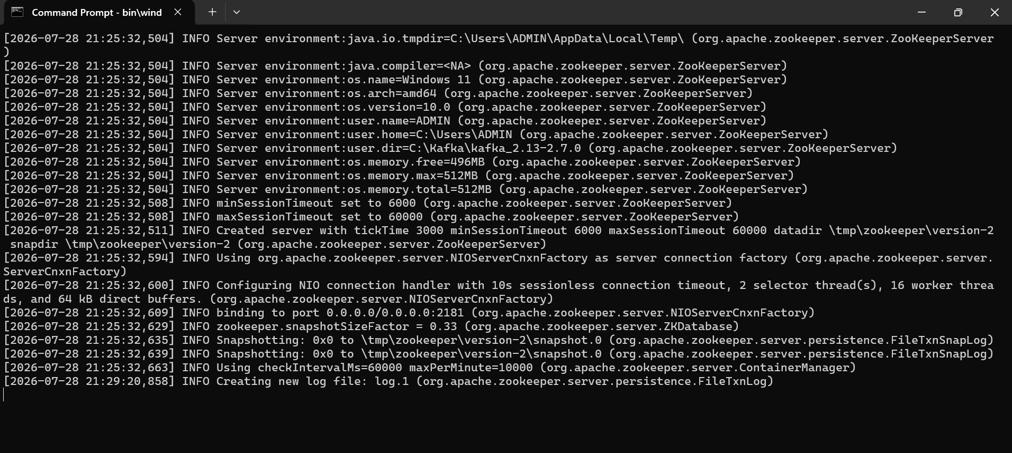

Figure 2:Kafka Server started successfully
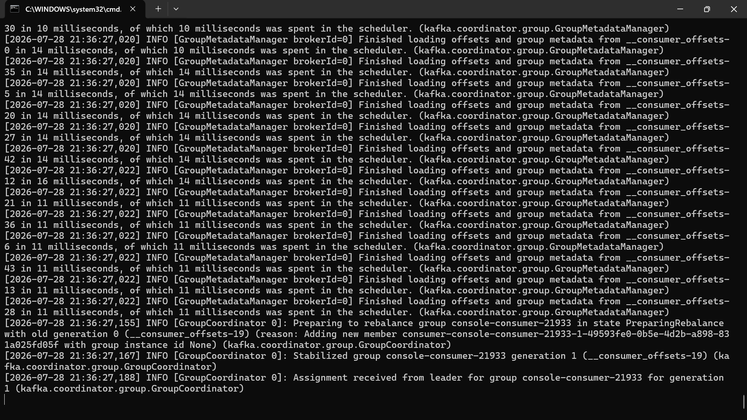

Figure 3:Kafka Topic (ChatTopic) created successfully

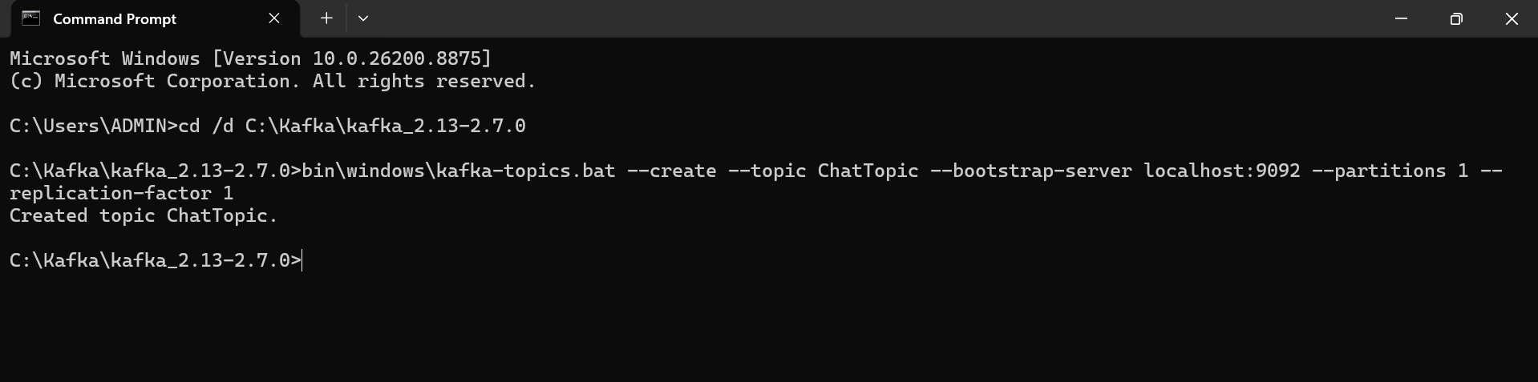

Figure 4:Kafka Producer publishing chat messages

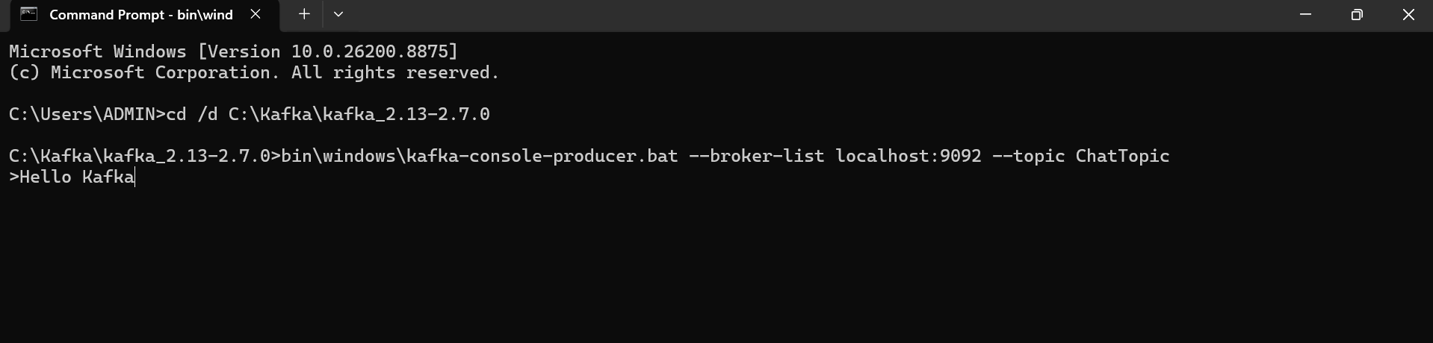

Figure 5:Kafka Consumer receiving chat messages

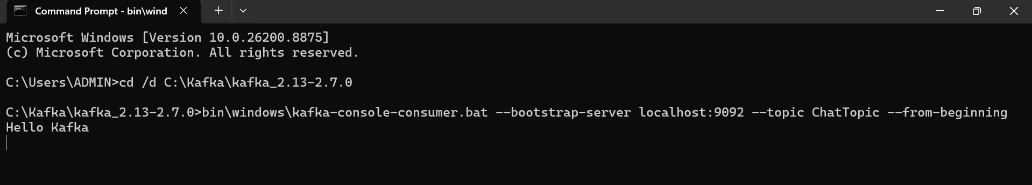
Result:
Successfully installed and configured Apache Kafka. The ZooKeeper and Kafka Server were started successfully, a Kafka topic was created, messages were published using the Kafka Producer, and the Kafka Consumer received the messages successfully, demonstrating real-time message streaming using Apache Kafka.

